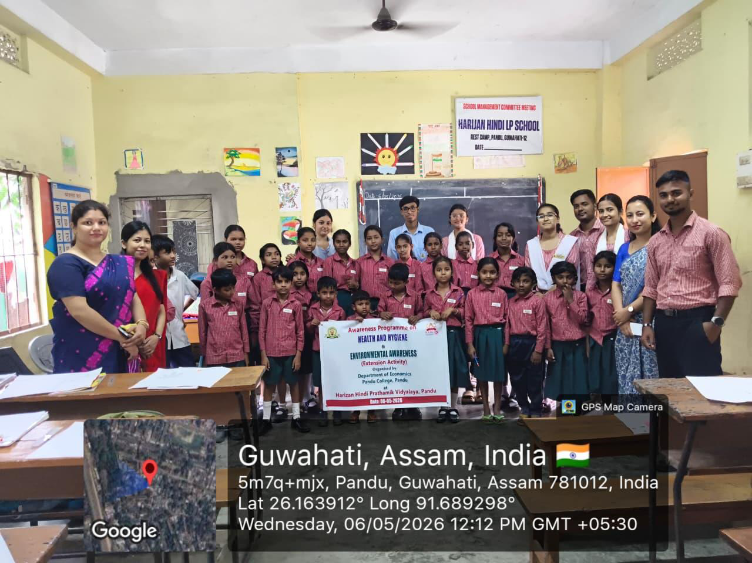

“Environmental Awareness” at Harizan Hindi Prathamik Vidyalaya, Pandu

