Workshop on “Introduction to Statistical Software for Social Science Research”

Date: April 24, 2025
Resource Person: Ms. Sarita Barman, Research Scholar, Department of Statistics, Cotton University
Venue: Computer Lab
Participants: 32 students
The Department of Economics, Pandu College, organised a one-day workshop titled “Introduction to Statistical Software for Social Science Research” on April 24, 2025. The objective of the session was to familiarise students with fundamental statistical tools and their application in social science research using statistical software.
The workshop began with a welcome address by the Head of the Department, Dr. Binita Tamuli Barman, followed by a brief introduction on the role of statistics in research design and data analysis by Mr. Bishal Das, Assistant Professor.
The technical session was conducted by Ms. Sarita Barman, who introduced participants to the basics of statistical software and demonstrated the following:
- Data entry and coding conventions
- Importing datasets and basic data cleaning
- Descriptive statistics (mean, median, standard deviation, frequencies)
- Graphical summaries (bar charts, histograms, box plots)
- Introductory inferential tools (correlation and simple hypothesis testing)
The workshop was designed as an interactive, hands-on training program. Students practiced each step using sample datasets provided during the session and received one-to-one guidance from the resource person.
At the end of the workshop, certificates of participation were distributed amongst the students as recognition of their successful completion of the training.
Outcomes
- Students gained foundational skills in navigating statistical software for research.
- Participants learned to summarise data, generate basic visuals, and perform introductory statistical tests.
- The workshop enhanced confidence in handling primary survey data for term papers and project work.

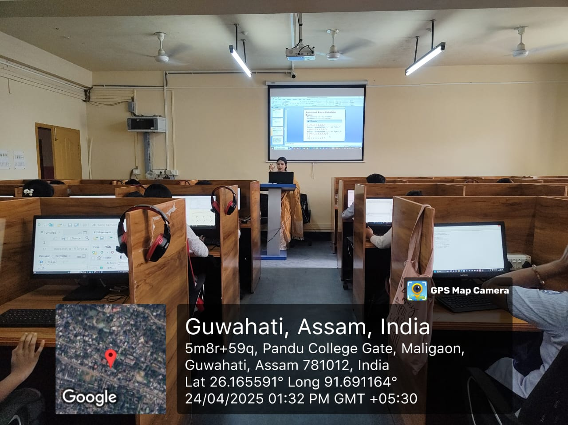

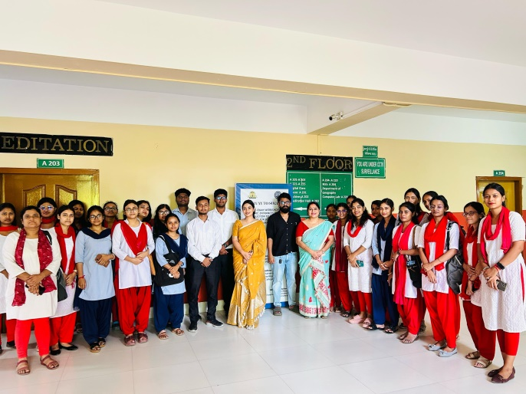
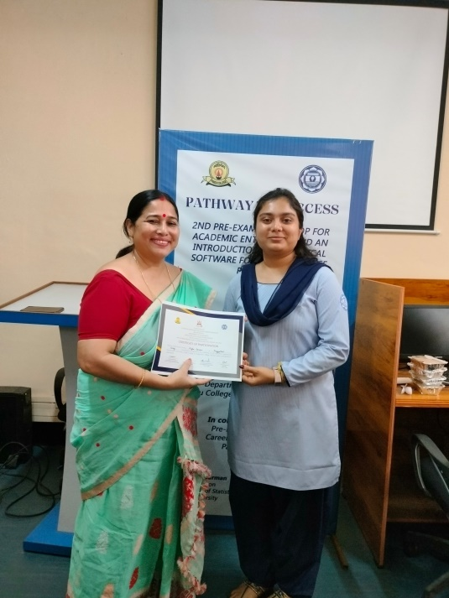.
Certificate:
