Navigating Mobile Phones and Social Media Responsibility - A Community-Based Programme
On December 9, 2023, the Department of Economics, Pandu College organized a community-based programme focusing on "Navigating Mobile Phones and Social Media Responsibility." The session was conducted by Dr. Mofidul Hassan, Assistant Professor in the Department of Economics, Pandu College. The programme aimed to address the importance and challenges associated with the use of mobile phones and social media in contemporary society. A total of 36 individuals, comprising both males and females from the nearby community, actively participated in the programme.
Dr. Mofidul Hassan, Assistant Professor of Economics, delivered an informative presentation on the significance and challenges of using mobile phones and social media responsibly. His presentation aimed to educate participants on the potential benefits and risks associated with the widespread use of these technologies.
Dr. Hassan emphasized the importance of using mobile phones responsibly, highlighting their role as powerful tools for communication, information access, and productivity enhancement. He discussed the various ways in which mobile phones contribute to social connectivity, educational opportunities, and economic empowerment. The resource person discussed the challenges posed by excessive mobile phone usage, including addiction, decreased productivity, and negative impact on mental health and interpersonal relationships. He discussed issues such as cyberbullying, misinformation, and digital footprint management, urging participants to adopt ethical and mindful practices in their online engagements. Dr. Hassan encouraged participants to actively engage in digital literacy initiatives and cultivate a culture of responsible digital citizenship within their communities.

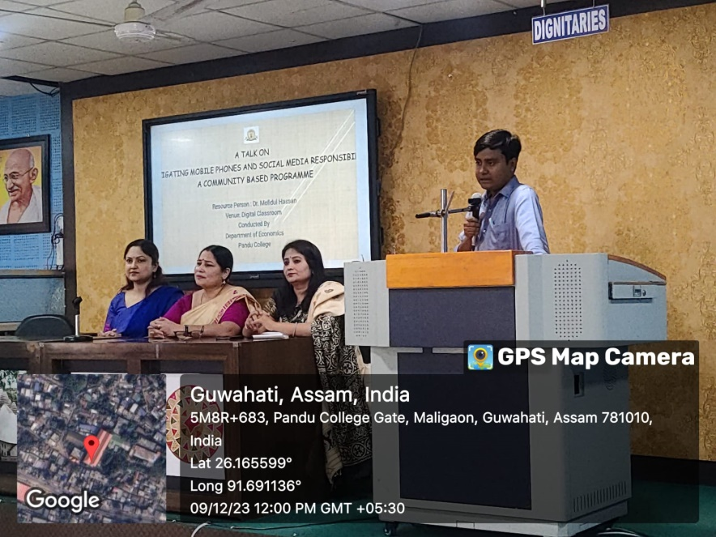

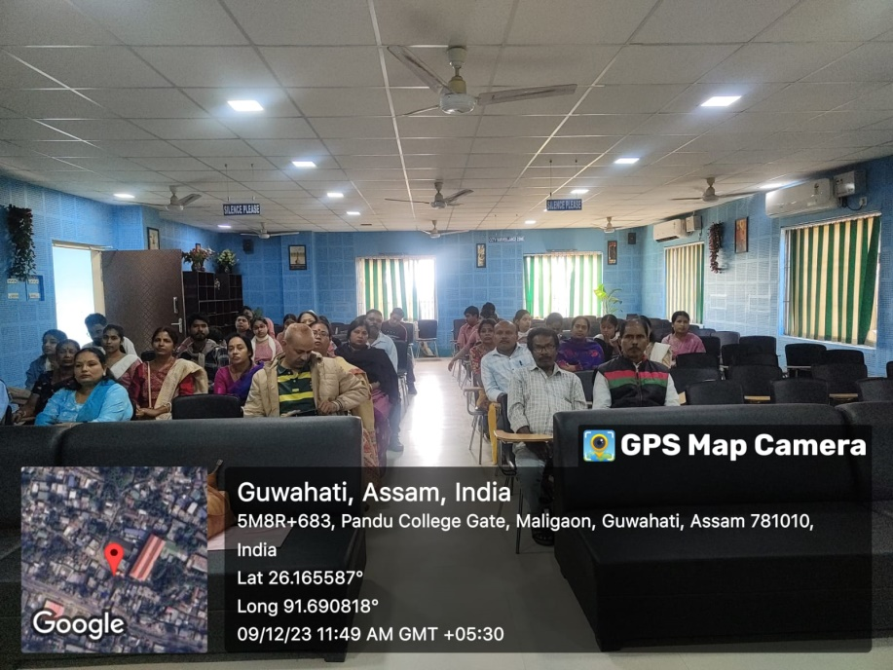

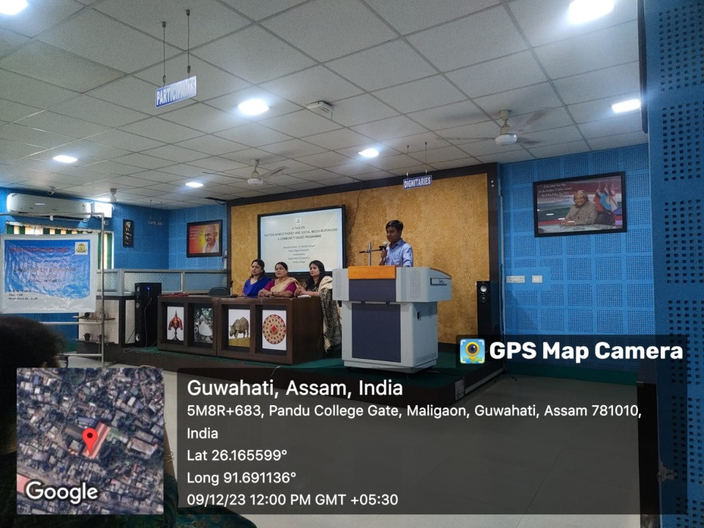
s

