Plantation Programme, 2018
Organised by:
Eco Club
Department of Botany
Pandu College

- Notice:

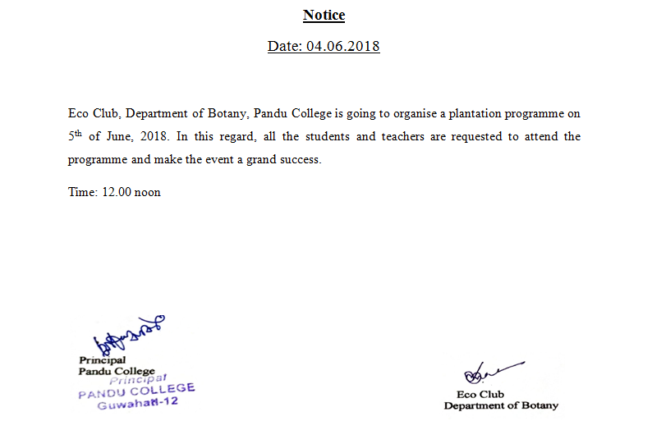

- Photographs of the activity register having name and signature of the participants:

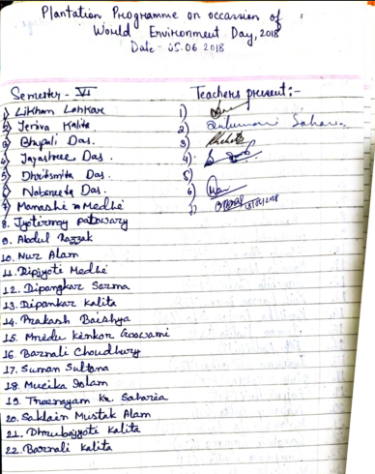

- Photograph of the programme:

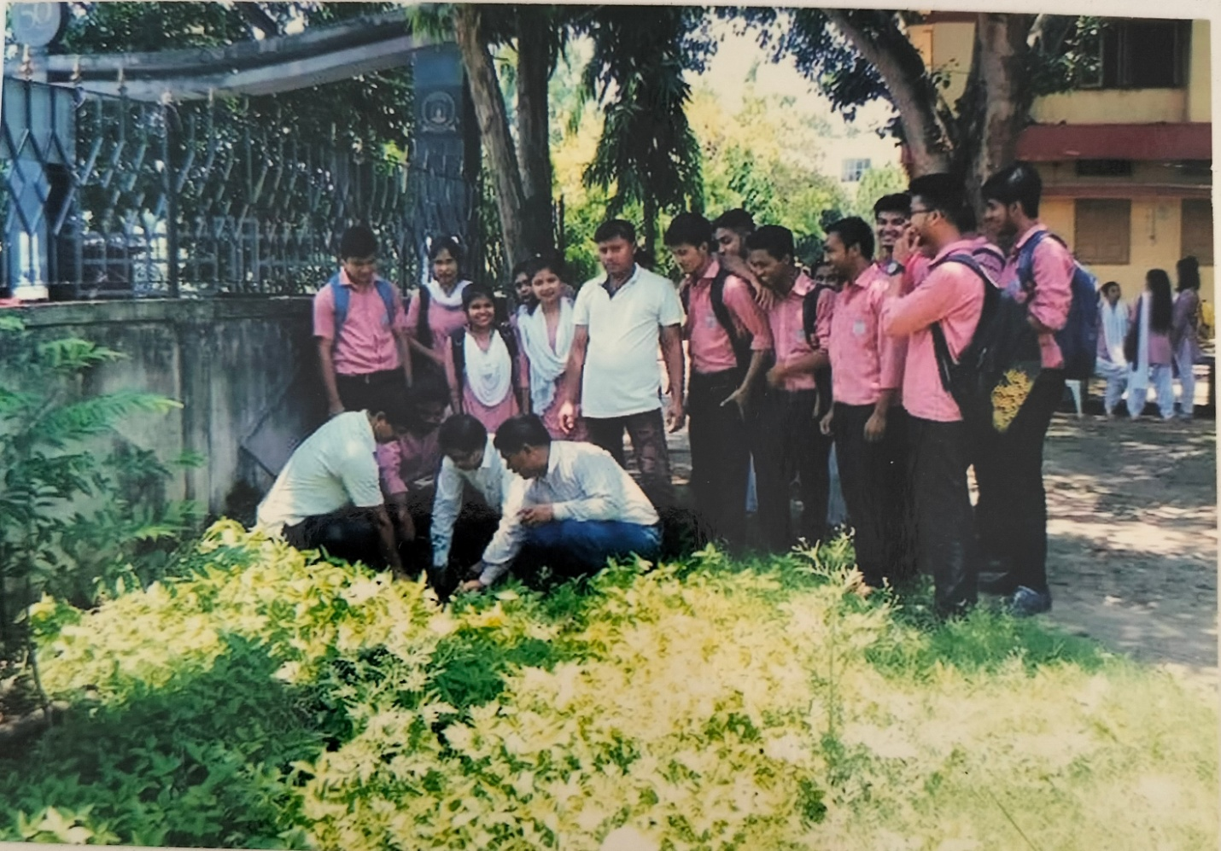

- Report of the event:
