Cultural Rally, 2019
Department of Botany
Pandu College

- Notice

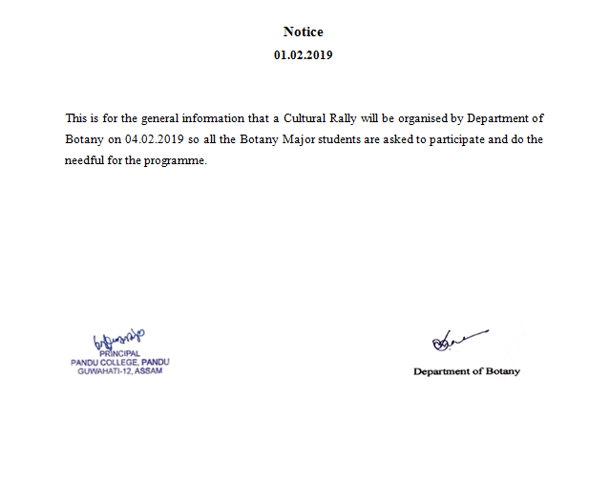

- Photographs of the event

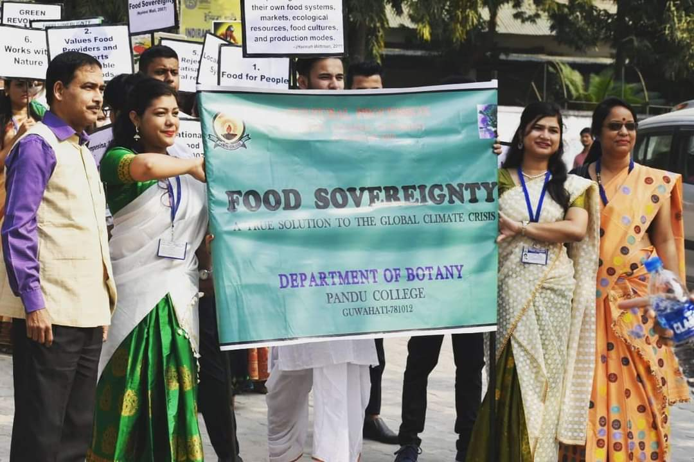

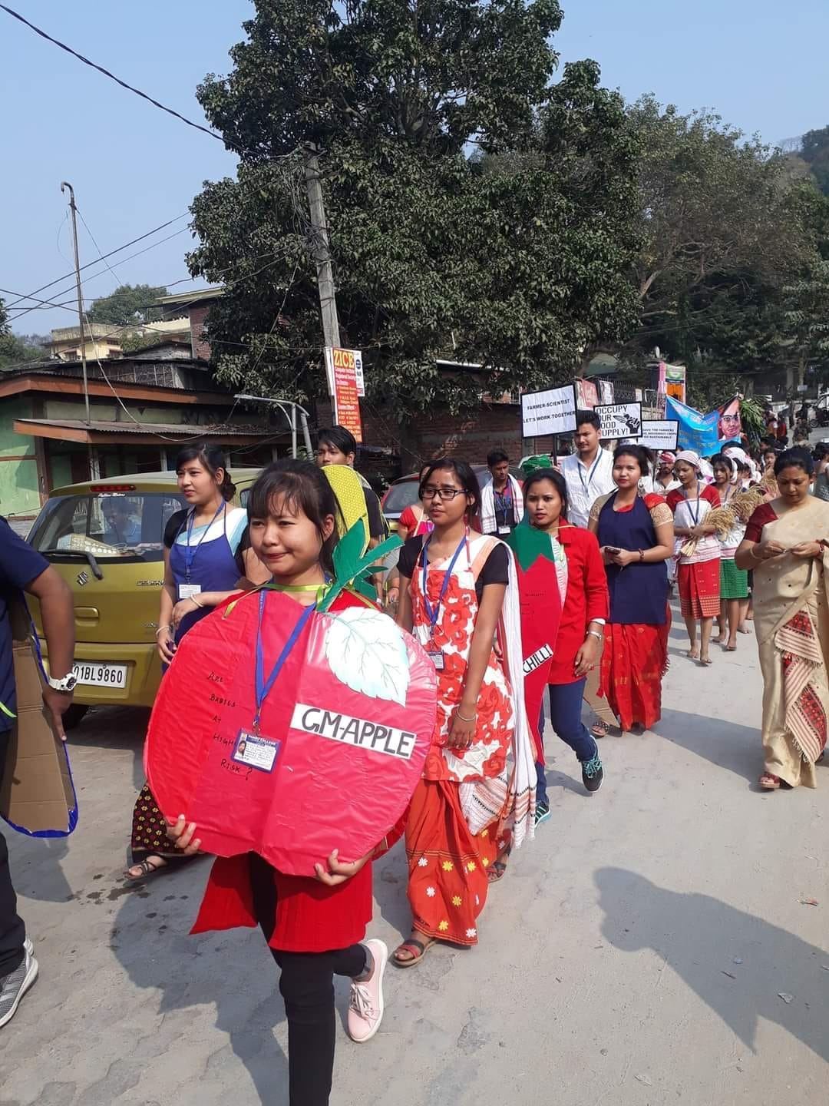

- Photograph of Student Signature

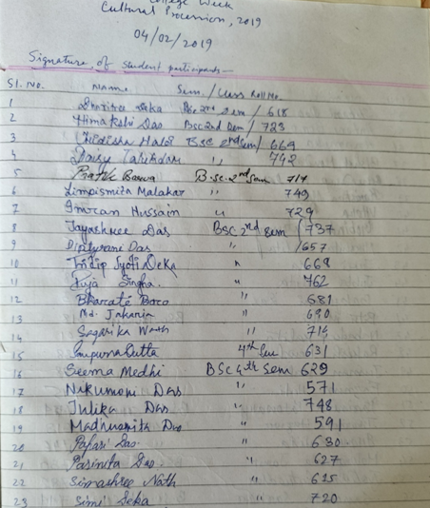

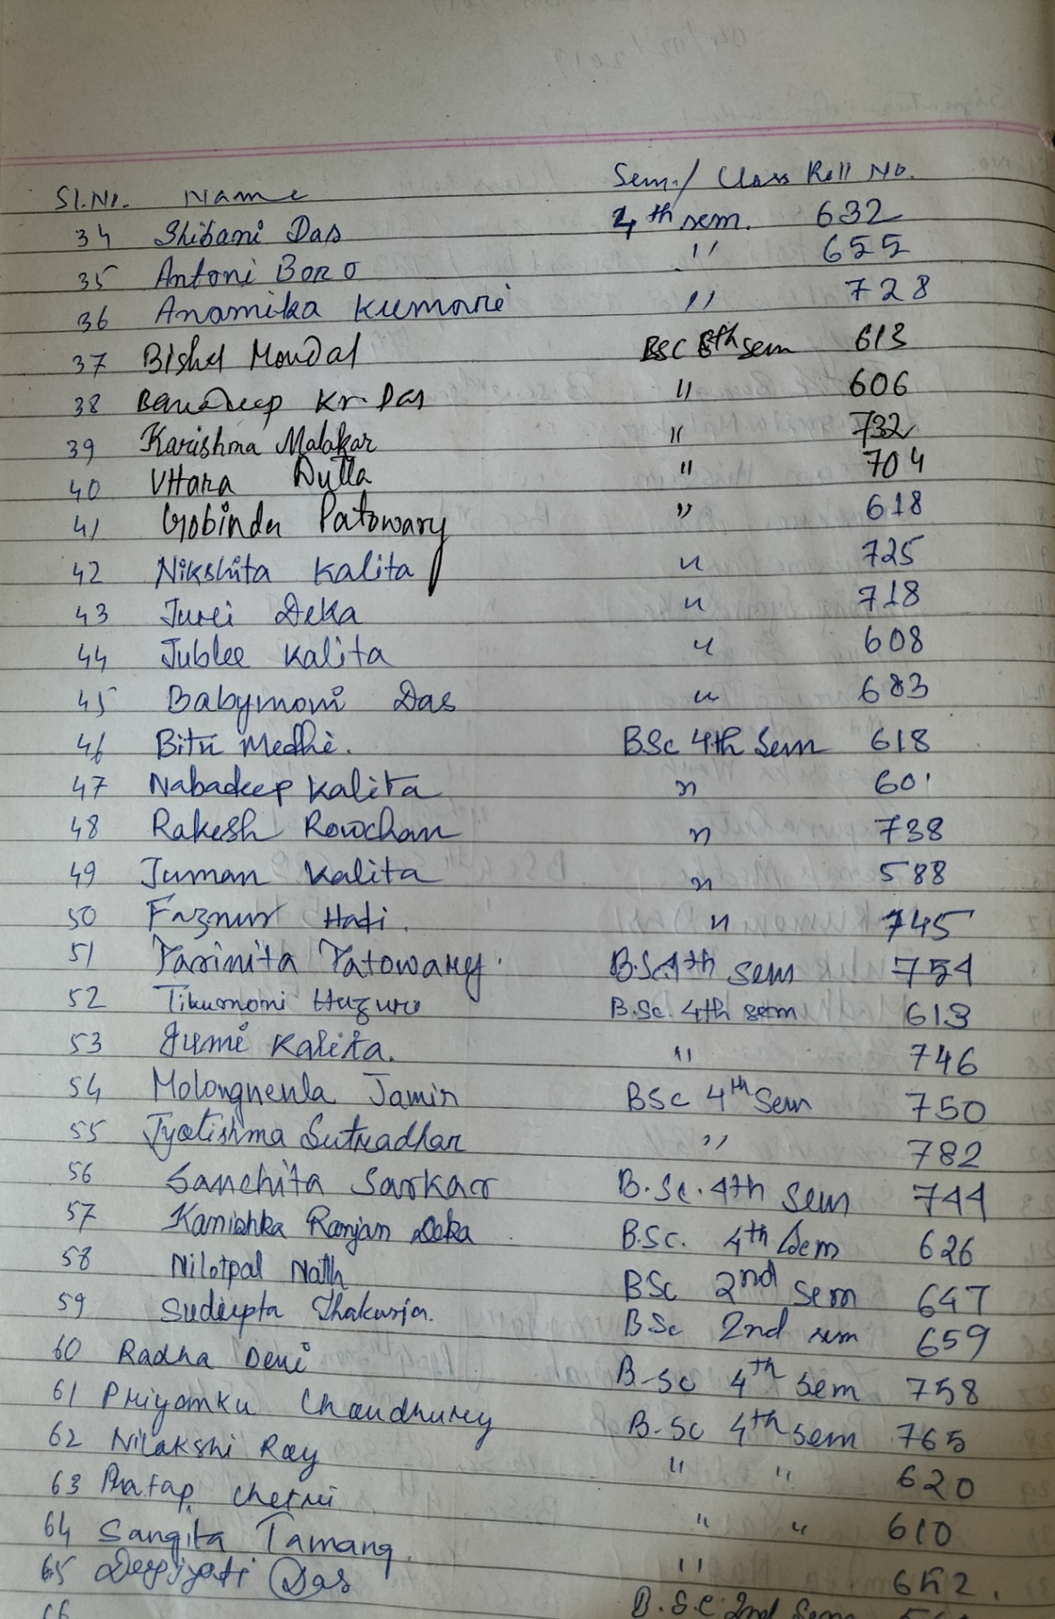

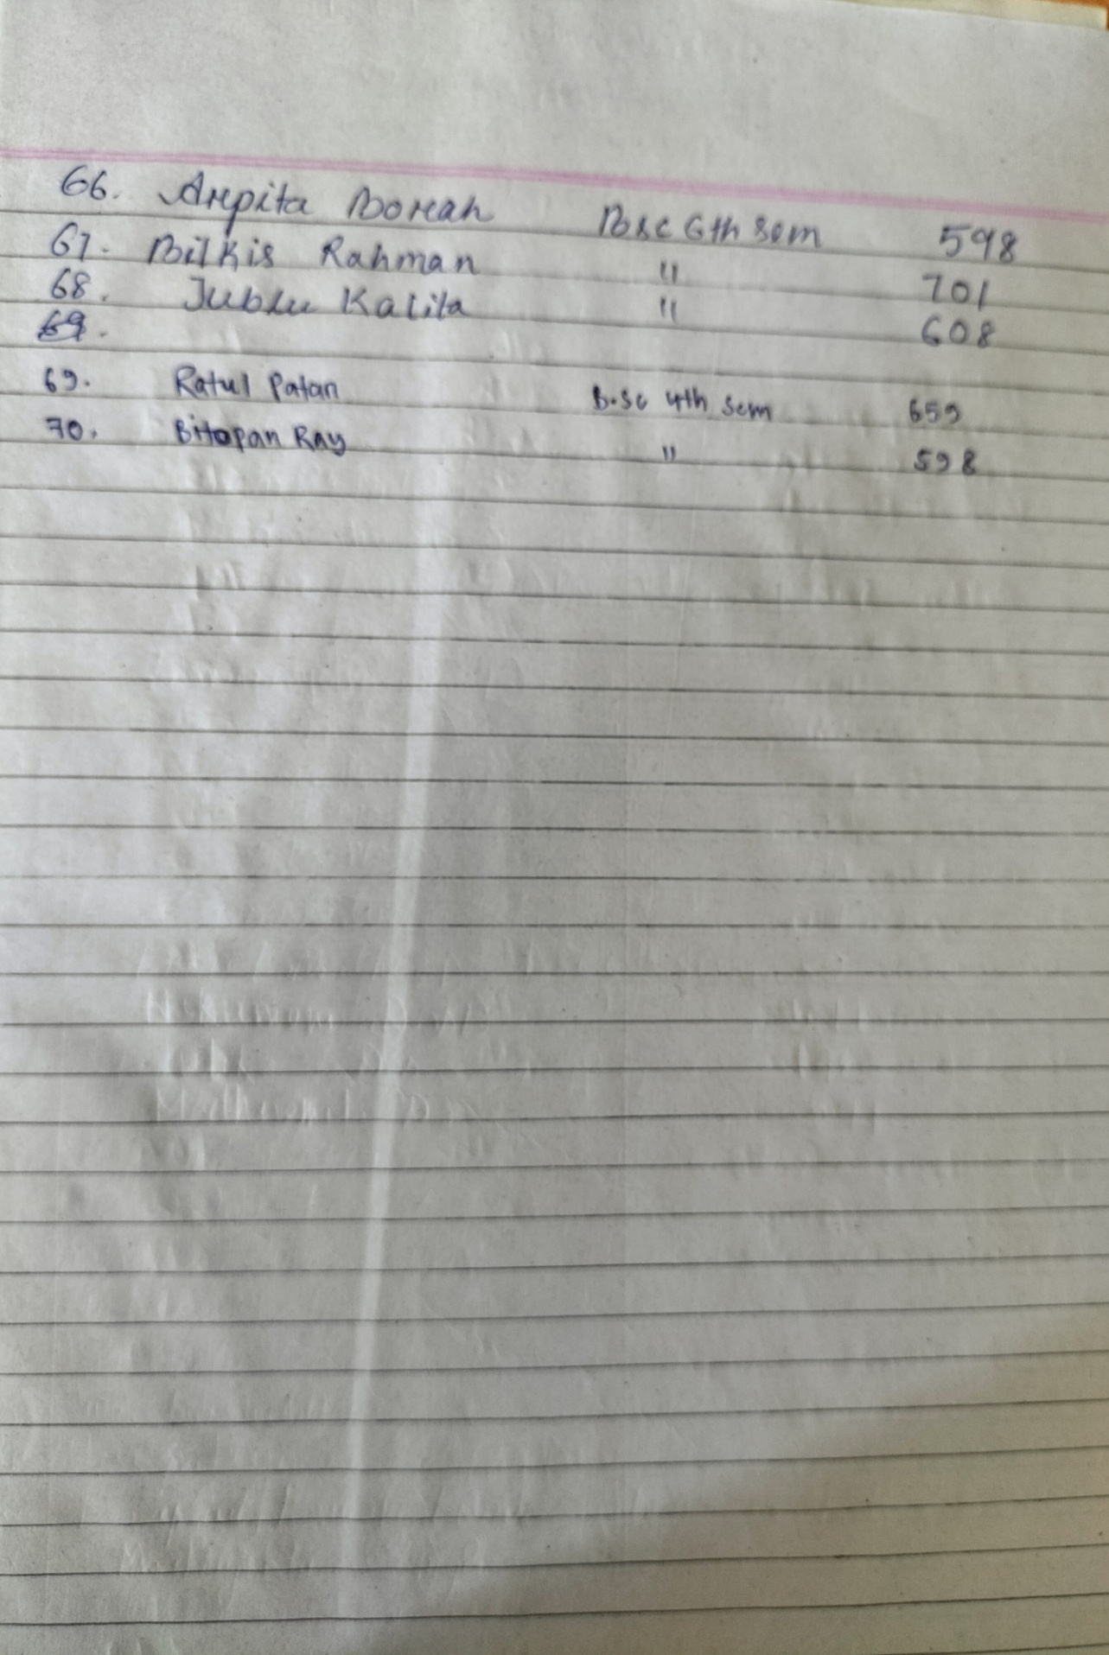

- Report
Department of Botany had organised a “Cultural Rally’ on 4th February, 2019 on the topic “Food Sovereignty”. This kind of programme provides a platform for students to showcase their talent, promote inclusivity and bond strong group activity. A total of 70 students participated in the programme.

