Field trip- Assam Bioresource Center, Madankamdev (04.04.2019)

- Notice & Permission-

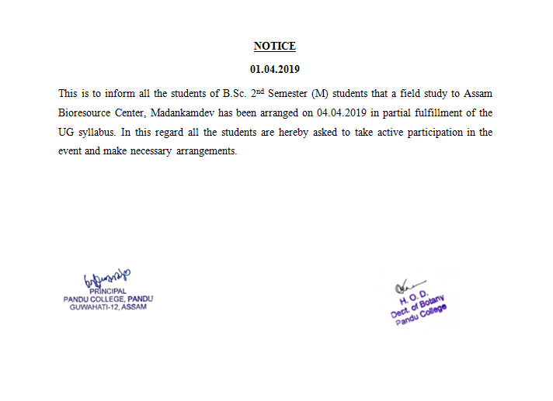

- Photographs-

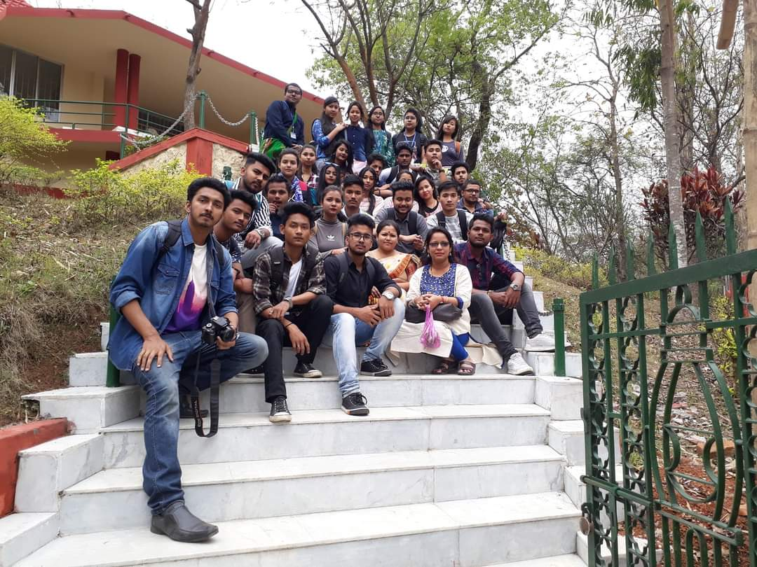

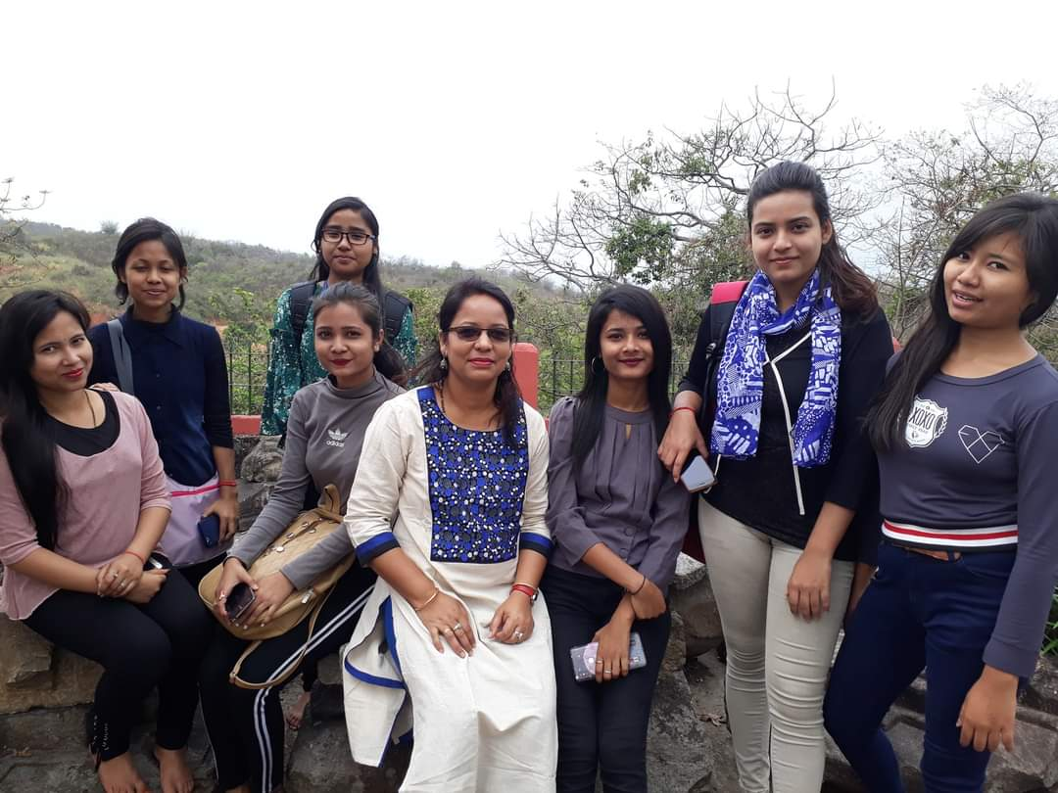

- List of Students
Sl.No. | Name of the Student
1 | Huidrom Pradip Kr. Singh
2 | Deepjyoti Das
3 | Bishal Hazarika
4 | Dharitree Deka
5 | Nilotpal Nath
6 | Ritu Das
7 | M. Prajokta Singh
8 | Dipti Rani Das
9 | Sudipta Thakuria
10 | Rajashree Das
11 | Tridip Jyoti Deka
12 | Imon Hussain
13 | Rituparna Bora
14 | Bharati Boro
15 | Muhammad Jakaria
16 | Amit Kumar Basumatary
17 | Jays Boro
18 | Mriganka Shekhar Kashyap
19 | Pratik Barua
20 | Daisy Talukdar
21 | Jayashree Das
22 | Sagarika Nath
23 | Imran Hussain
24 | Dwithun Basumatary
25 | Puja Singha

- Report of field trip-

