Cultural Rally, 2023
Department of Botany
Pandu College

- Notice:
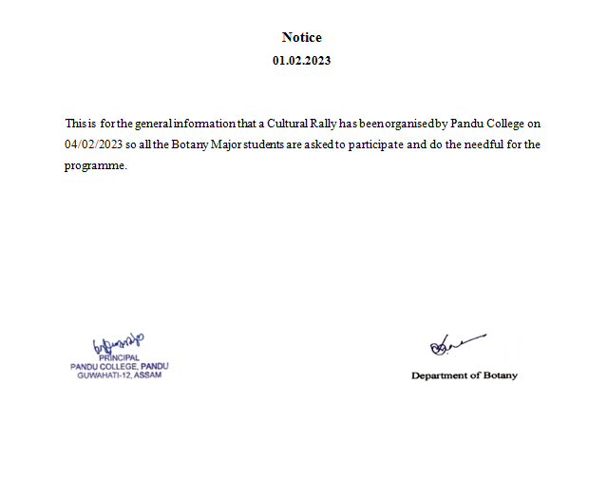

- Photographs of the event:

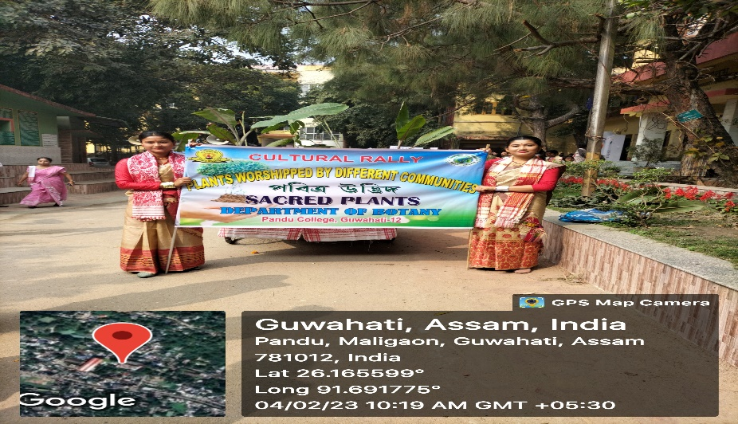

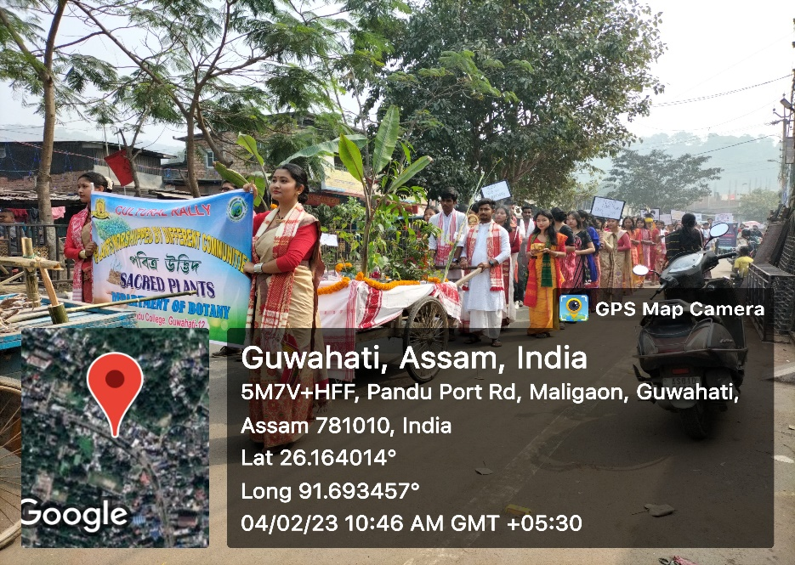
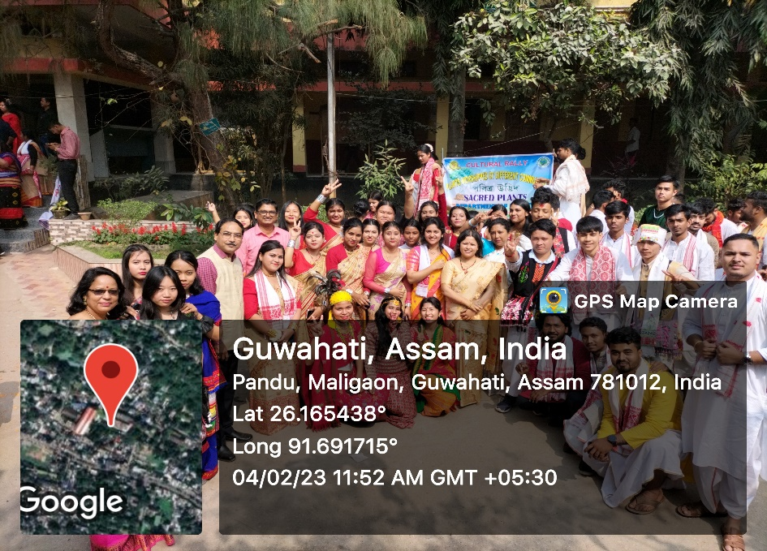

- Photograph of activity register:
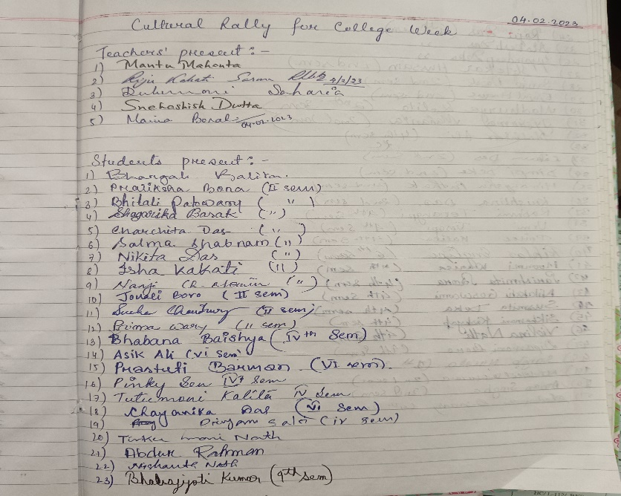
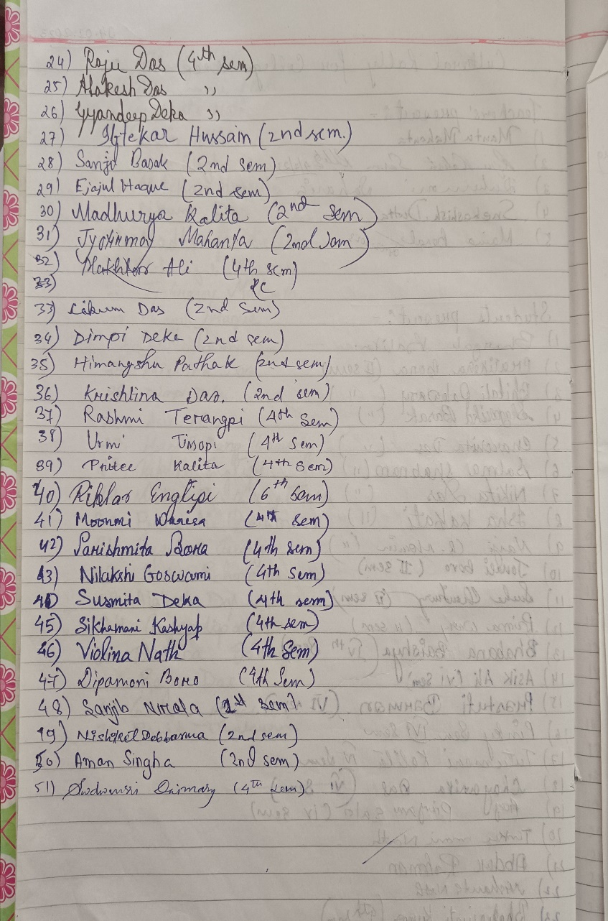

- Report

Department of Botany participated in the “Cultural Rally’ on 4th February, 2023. This kind of programmes provides a platform for students to showcase their talent, promote inclusivity and bond strong group activity. Keeping this in mind, Botany Department had performed under the theme “Plant worshipped by different communities”. A total of 51 students participated in the programme.

