Quiz Competition
Department of Botany
Pandu College

- Notice
This is for the general information that a Quiz competition will be organized for B.Sc 6th Sem (H) from the topics of R-DNA technology on 02/03/2024. All the student are asked to be present positively.

- Photograph of the event

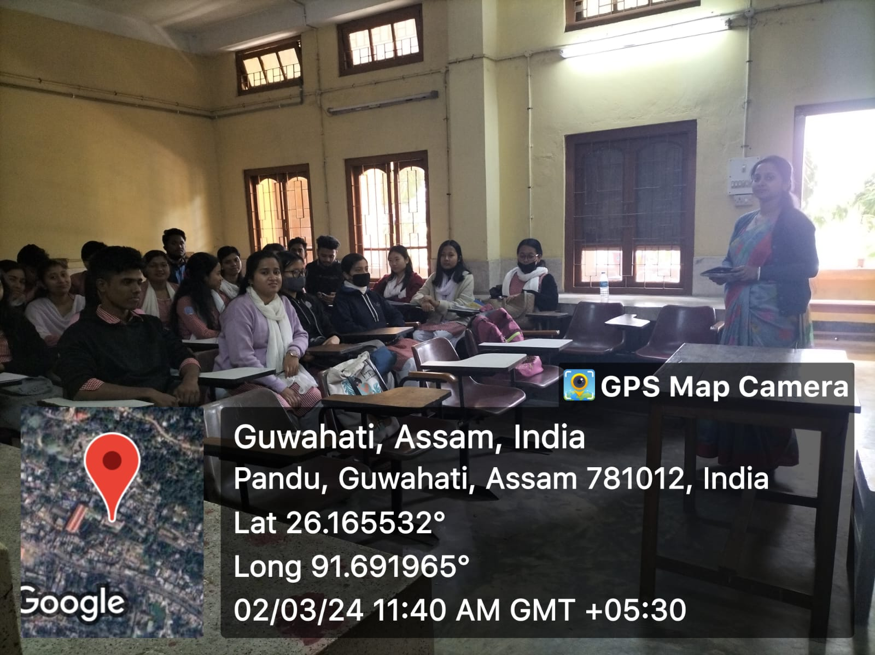

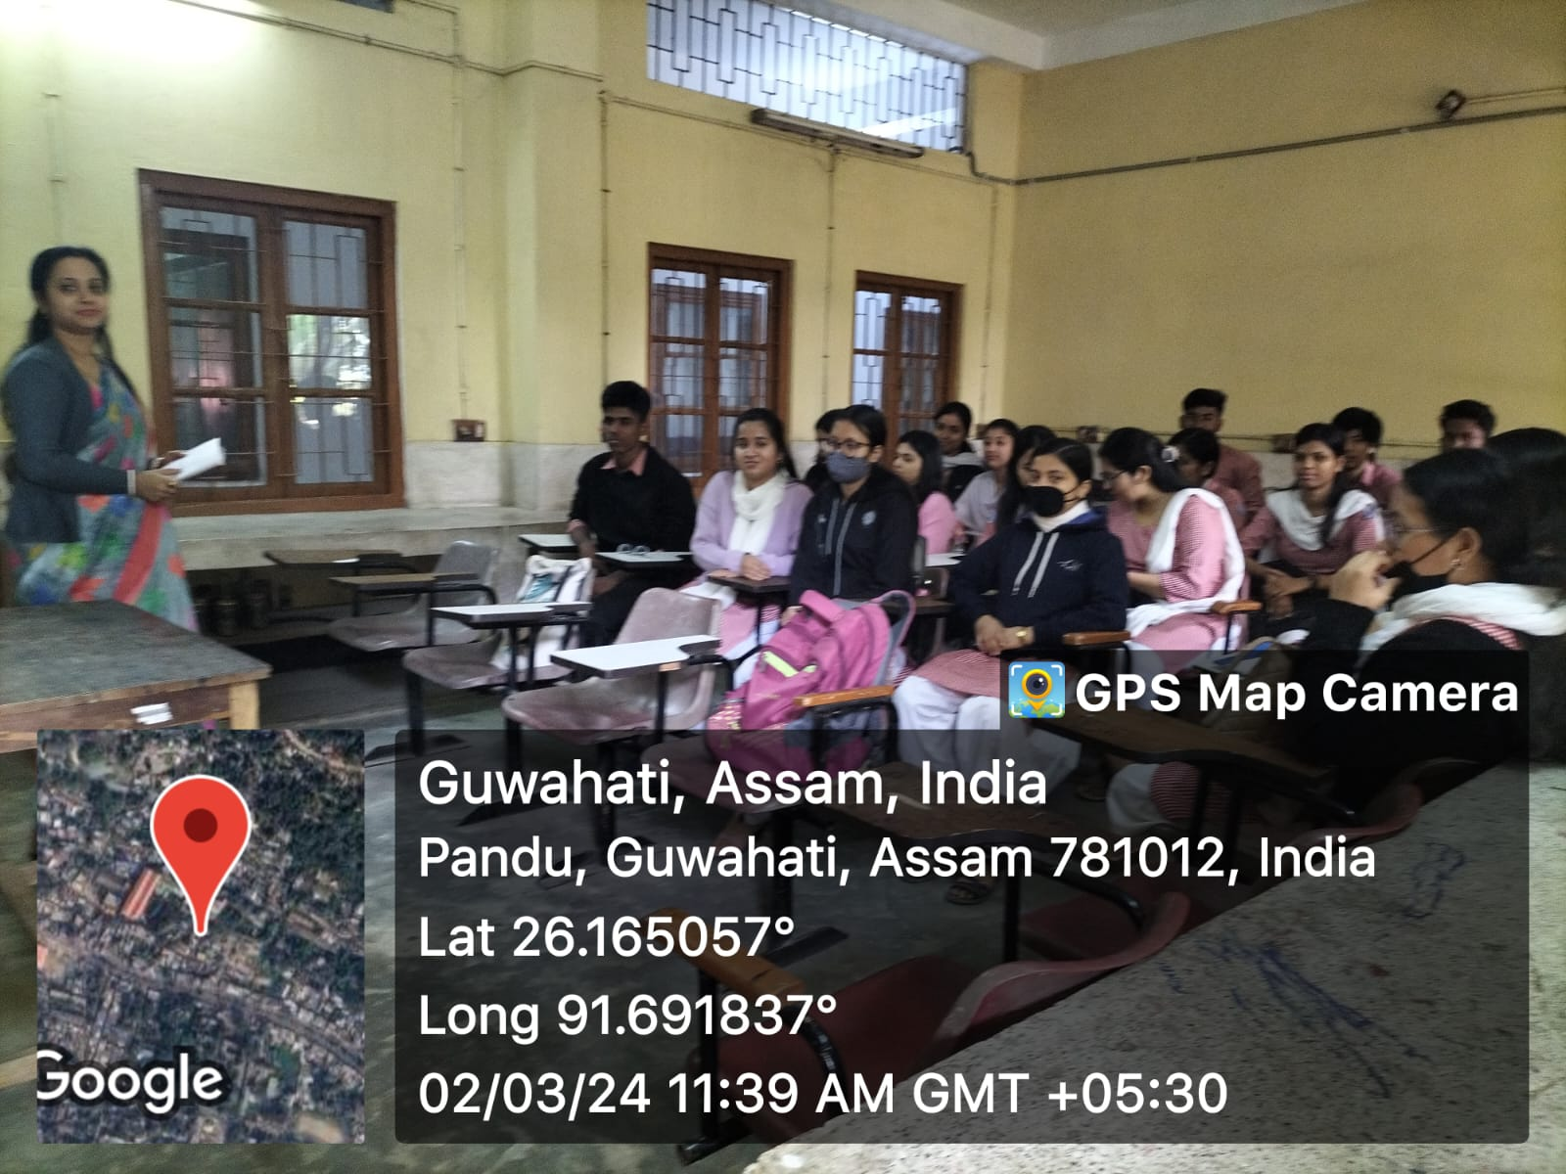

- Photograph of the Student signature:

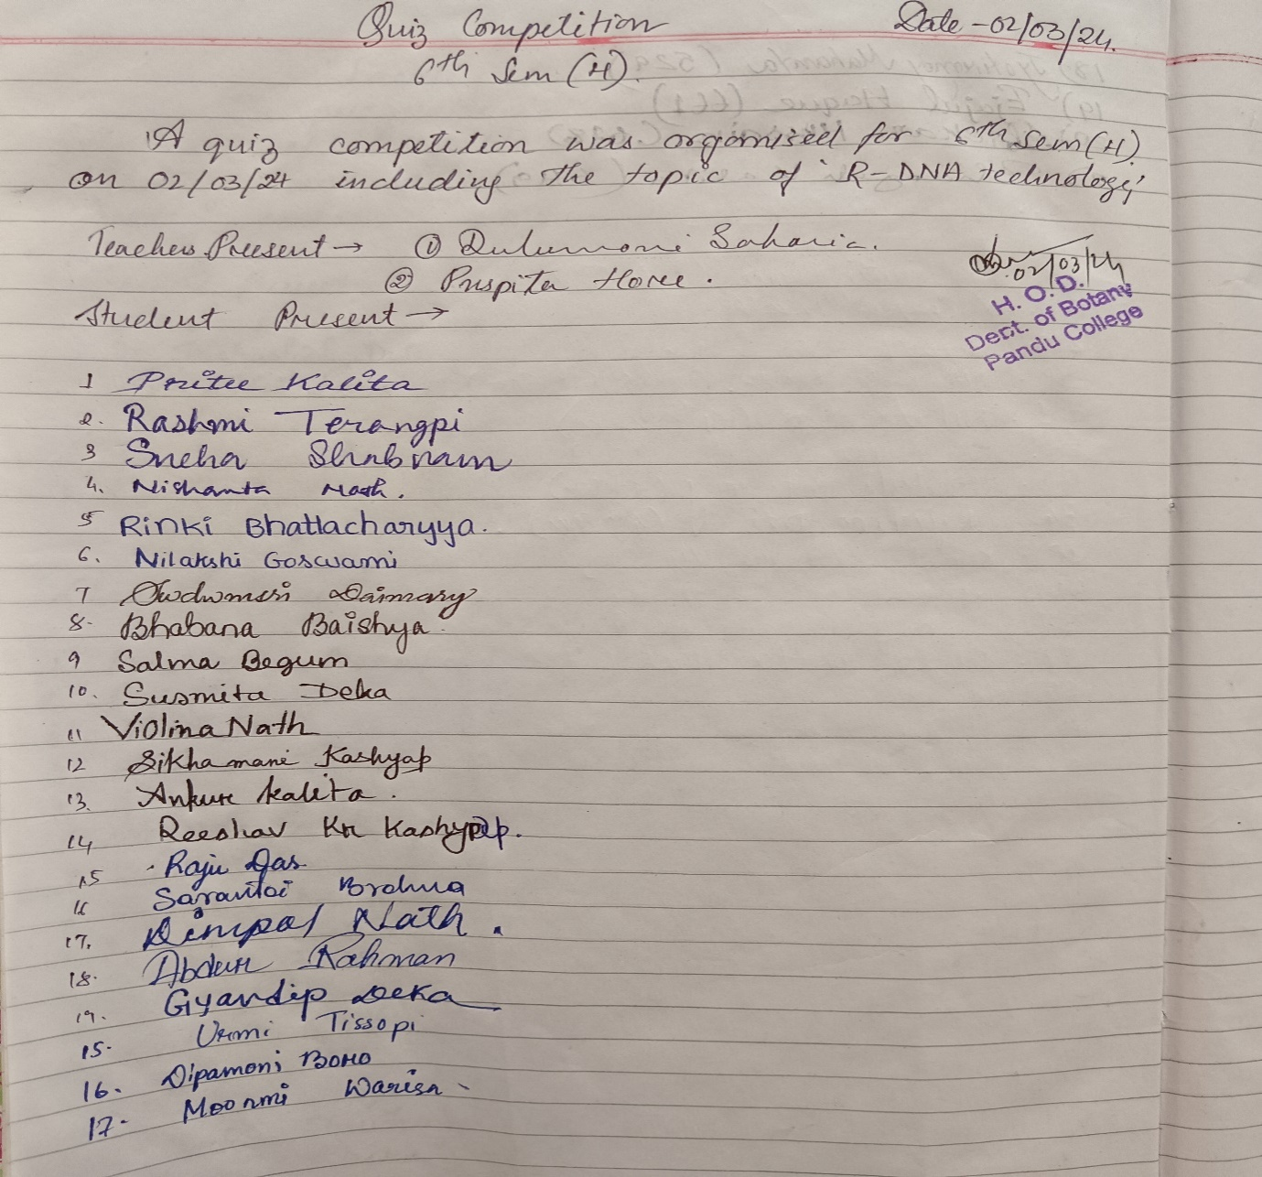

- Report

A quiz competition was arranged for B.Sc. 5th Semester (H) students on 02.03.2024. Quiz competitions helps to comprehend the subject matter and interactive skill over the subject matter. It helps to gather thorough knowledge on the discussed topic.

